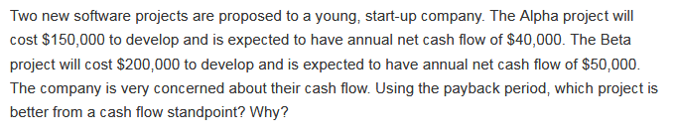

Payback period is the model that helps in estimating the time that is required to recover the investment made on the project.

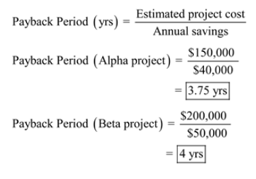

Since payback period for Alpha project is less, so Alpha Project is better from cash flow stand point.